**CSEE5590/490: Web/Mobile Programming (Spring 2019)**

**LAB ASSGINEMENT 4**

**Team ID:- 2**

Boyapati Ramya Class id-4

Manda Aparna Class id – 14

Yenugu Lohitha Class id - 34

YouTube Link:  <https://youtu.be/TIbU60vwBm4>

**Face Detection Application**

**1.Home Page**

In the Home Page we have a start button. By clicking on the start button we will be navigated to the Face Detection screen.

**2.Face Detection**

In the Face Detection screen, we have a Select Image button. By clicking on this button the user can upload a new photo using camera or select an existing photo from the gallery. Once the image is selected the user can click on the Detect button to view the human faces and facial features. The user can click on the View Log button to view the logs of the result

**Workflow of the Application:**

* In the Home Page, we have a start button .

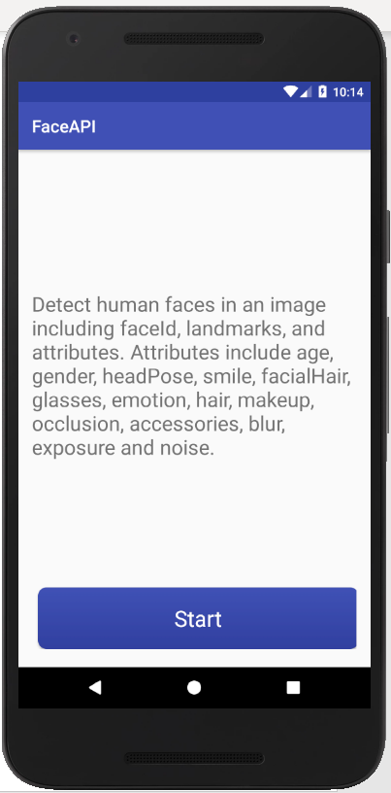

* On clicking start button we will be navigated to Face Detection screen.

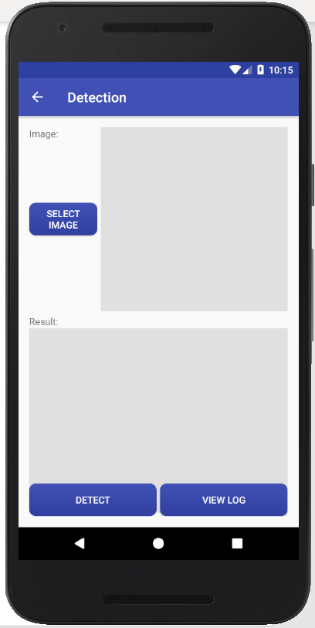

* On clicking Select Image button, the user can upload new photo or existing photo. To take a new photo using camera, the user can click on the Take A Photo button or to select an existing photo from the gallery , the user can click on From Gallery button.
* 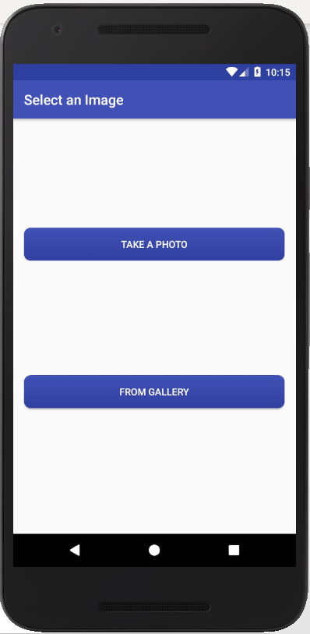
* On clicking Take A Photo button, camera will be opened where the user can take a photo.

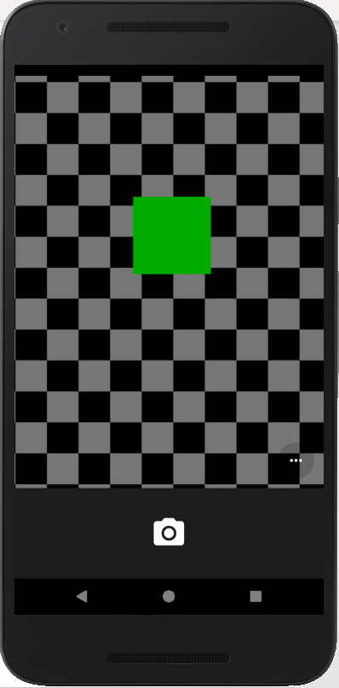

* On clicking From Gallery button, the user will be shown device images from which the user can select an image.

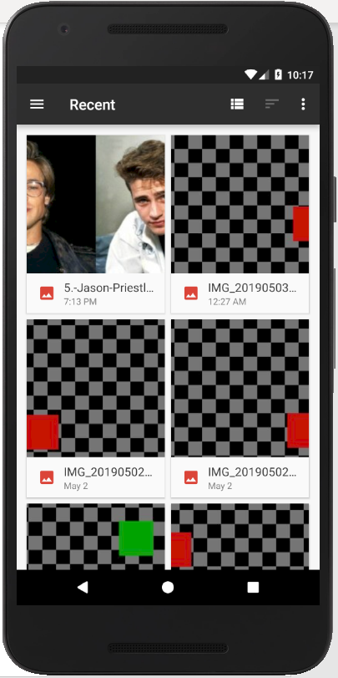

* After selecting an image , the user can click on Detect button to detect the faces and facial features in the photo.
* 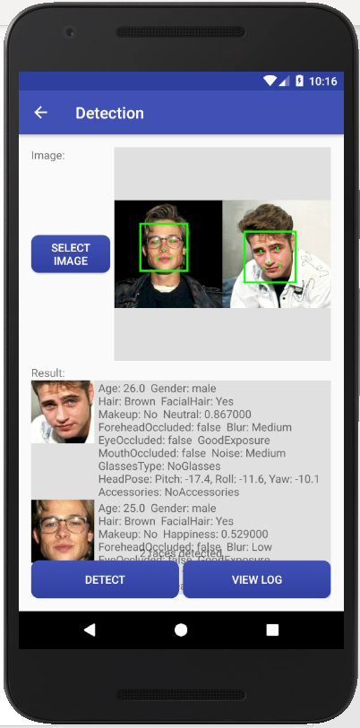
* On clicking View Log button , the logs of the result will be shown.
* 